Cross Site Scripting Labs On Portswigger

I want to inform you that I have solved 5 Cross Site Scripting labs on Web Security Academy by Porswigger.

Website:- https://portswigger.net/web-security/all-labs

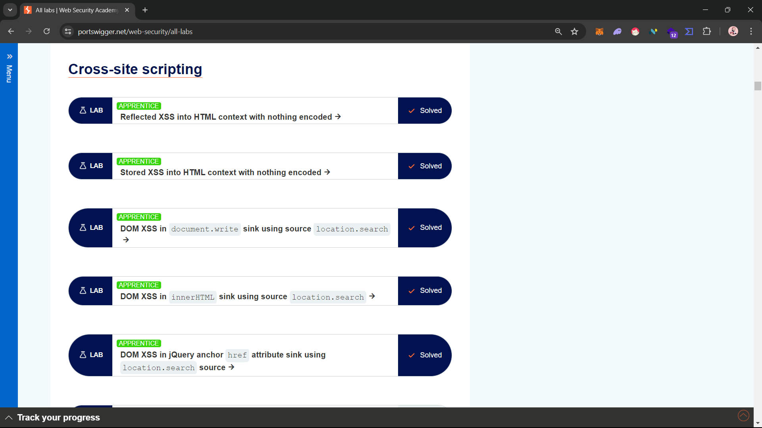
The labs I have solved are as follows:-

1. Reflected XSS into HTML context with nothing encoded

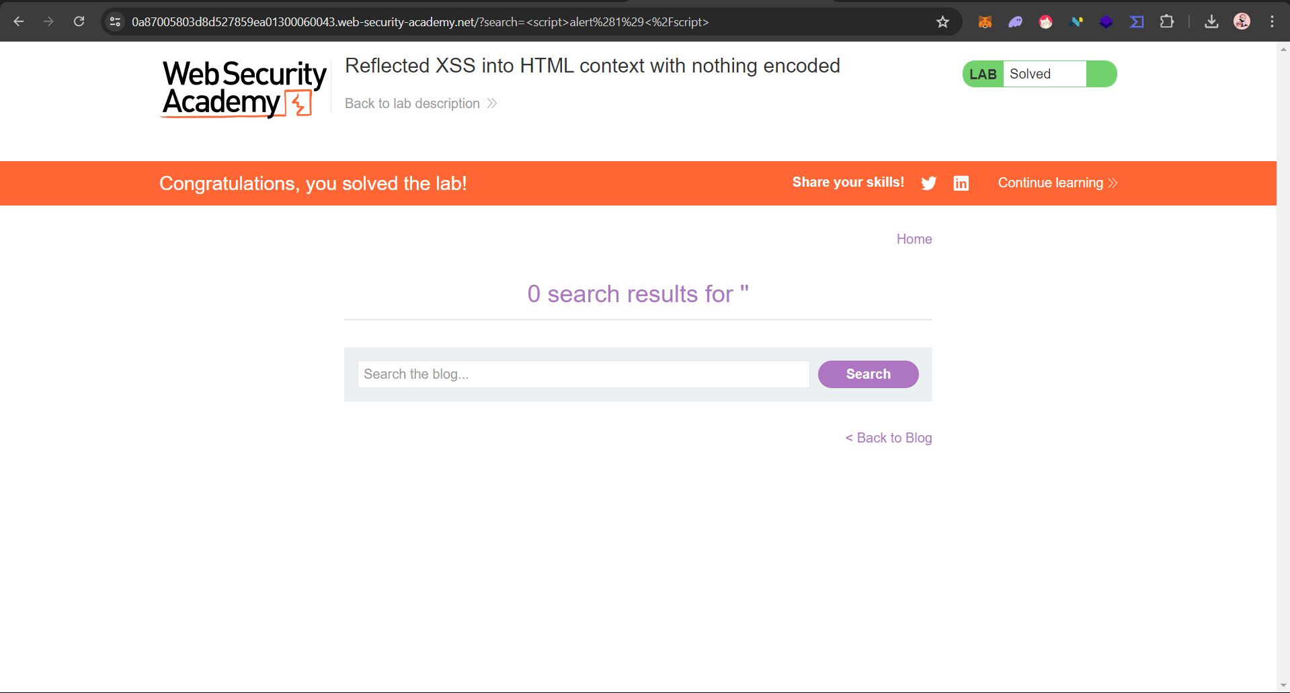

2. Stored XSS into HTML context with nothing encoded

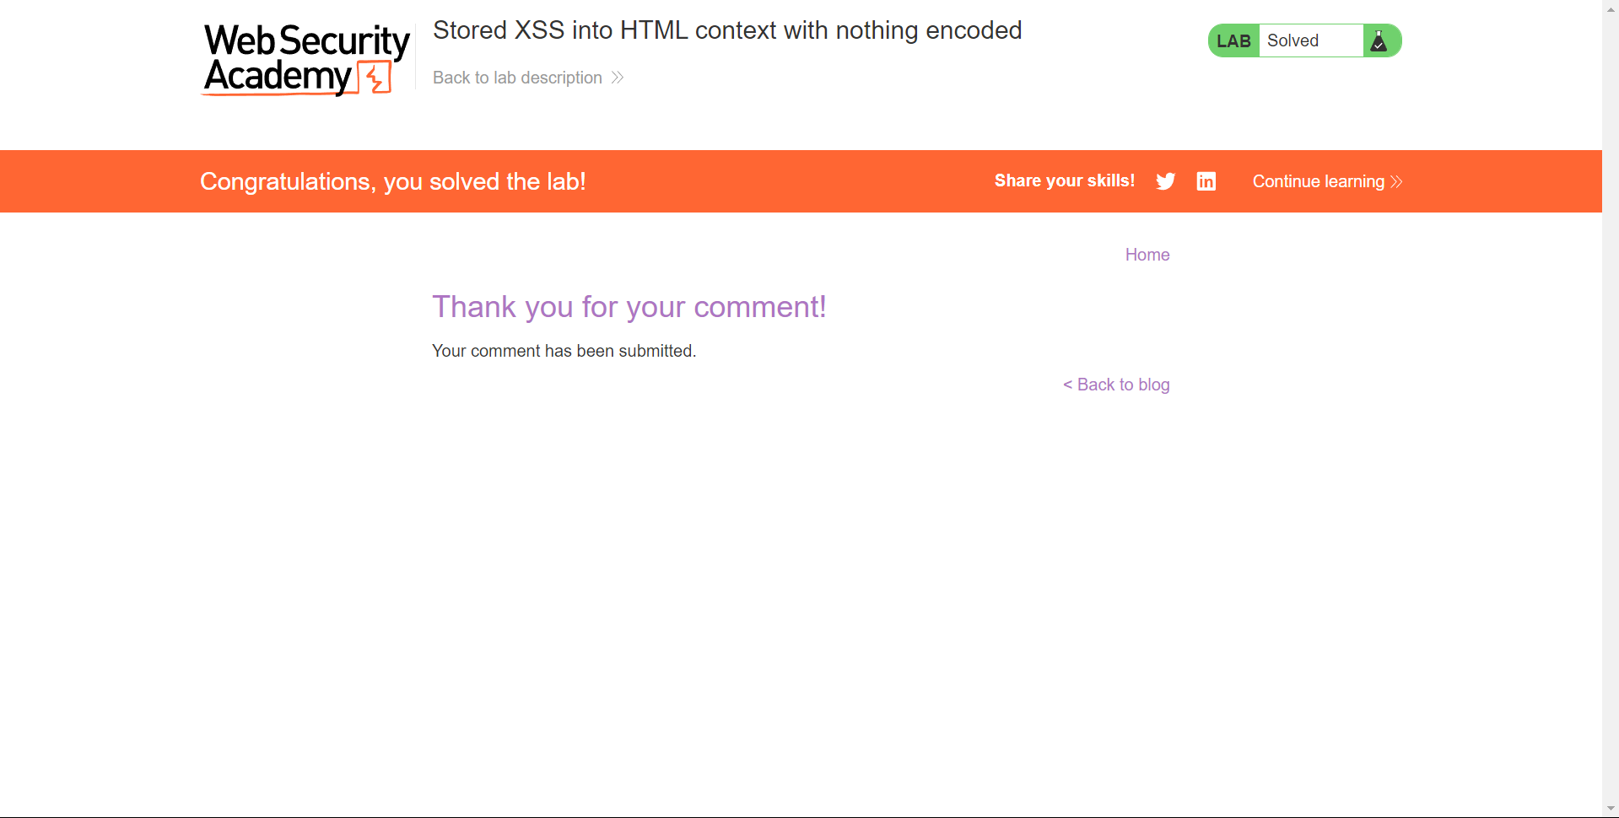

3. DOM XSS in document.write sink using source location.search

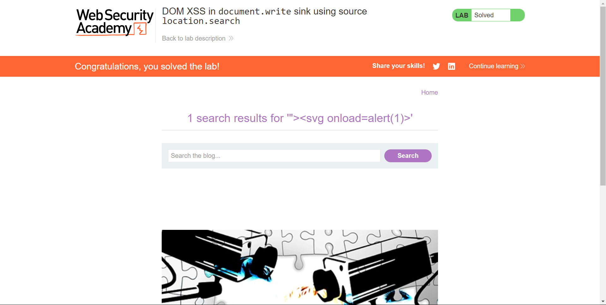

4. DOM XSS in innerHTML sink using source location.search

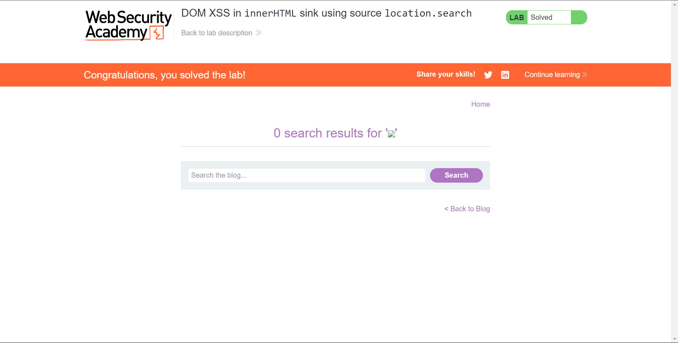

5. DOM XSS in jQuery anchor href attribute sink using location.search source

